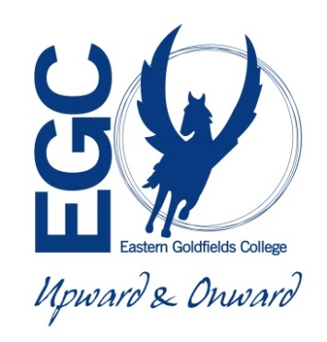**ATAR HUMAN BIOLOGY**

**Unit 2**

**Task 12 : Genetics & Inheritance Test**

**Name:**  **Weighting 5%**

**Date:**  **Mark /**

1. There are TWO sections in this test, Multiple Choice and Short Answer
2. This is a closed book assessment (no notes are allowed).
3. The time allowed to complete the test is 60 minutes.
4. Write your answers to the Multiple Choice section on the **separate** answer sheet provided.
5. Write your answers to the Short Answer section in space provided.
6. Write your answers to the Extended Answer section in space provided.

|  |  |  |
| --- | --- | --- |
|  | **Marks Allocation** | **Your Total** |
| **Multiple Choice** | 12 |  |
| **Short Answer** | 38 |  |
| **TOTAL** | 50 |  |

**ATAR HUMAN BIOLOGY UNIT 2**

**TASK 12 : GENETICS & INHERITANCE**

**Name: _________________**

**Multiple Choice Answer Sheet**

Answer all questions by circling the letter corresponding

to the most correct answer.

1. A B C D

2. A B C D

3. A B C D

4. A B C D

5. A B C D

6. A B C D

7. A B C D

8. A B C D

9. A B C D

10. A B C D

11. A B C D

12. A B C D

**Part A - Multiple Choice Questions (12 Marks)**

1. The genotype of an individual:
   1. is always the same as the phenotype.
   2. refers to the visible trait of that individual.
   3. is indicated by the presence of either an X or Y chromosome.
   4. refers to the composition of the genes.
2. A family has five sons. The theoretical probability that the sixth child will be a daughter is:
3. one chance in two.
4. one chance in five.
5. one chance in six.
6. five chances in six.

Questions 3 and 4 refer to the following pedigree showing the inheritance of haemophilia.



1. What is the chance of female 5 being a carrier?
2. 0
3. 25%
4. 50%
5. 100%
6. If female 5 is a carrier and she marries a normal male, what are her chances of producing a haemophiliac child?
7. 0%
8. 25%
9. 50%
10. 100%
11. Which of the following forms of contraception will prevent the spread of STI’s?
12. Diaphragm
13. IUD
14. Morning after pill
15. Femidom
16. In which of the following situations would sex selection not be ethically recommended?
17. There is a history of Duchenne muscular dystrophy in a family.
18. The mother is a known carrier of haemophilia.
19. The family already has five children of the same sex.
20. The father is a haemophiliac.
21. ART procedures can be used when a couple is having difficulty conceiving a baby. All the following procedures involve fertilisation outside of the body except for:
22. GIFT
23. IVF
24. ZIFT
25. ICSI
26. A mutation is best described as:
27. a permanent change in genetic material causing death.
28. a new characteristic appearing in an organism.
29. a change in the mitotic process.
30. treatment by radiation.
31. An individual who is heterozygous for a genetic trait will:
32. be a carrier for the recessive trait.
33. not physically show the dominant trait.
34. not pass the recessive allele to their offspring.
35. only have offspring who are also heterozygous.
36. Red-green colour blindness is an X-linked recessive disorder. A mother with this condition will pass this allele to:
37. her daughters only.
38. her sons only.
39. none of her children.
40. all of her children.
41. A couple both with the ability to roll their tongues had a son that could not roll his tongue. Being able to roll your tongue is a dominant trait. The couple assumed that:
42. their child inherited a mutation which meant he could not roll his tongue.
43. they were both carriers of the allele for non-tongue rolling.
44. they were both homozygous.
45. their son would eventually be able to roll his tongue.
46. Which of the following STI’s is now routinely vaccinated against in Australia?
47. herpes
48. Chlamydia
49. HPV – Human Papilloma virus
50. Gonorrhea

**Short Answer Section (38 marks)**

**Question One (5 marks)**

The type of hair a person inherits is controlled by a pair of alleles. When two people with wavy hair are crossed the following phenotypic ratios are present in their offspring: 25% curly hair, 25% straight hair and 50% wavy hair.

1. What could the genotypes of the wavy haired parents be? ________________________ (1 mark)

b) Explain what type of inheritance is exhibited in the appearance of the hair. (2 marks)

_____________________________________________________________________________________________________________________________________________________________________________________________________________________________________________________________________________________________________________________________________________________________________________________________________________________

c) Draw a punnet square to show the possible offspring of a wavy haired person crossed with a curly haired person. (2 marks)

**Question Two (3 marks)**

Pedigree charts are extremely useful for individual family members to identify if they might be a carrier of diseases and conditions that they do not want to pass on to offspring. If individuals are concerned and there is a risk, then they can use DNA profiling to help identify if they are in fact a carrier.

a) Explain what is meant by DNA profiling. (2 marks)

____________________________________________________________________________________________________________________________________________________________________________________________________________________________________________________________________________________________________________________________________

b) Apart from testing for genetic disease where else could DNA profiling be used? (1 mark)

_________________________________________________________________________________

**Question Three (7 marks)**

Below is a pedigree chart showing a family history of Ocular Albinism.

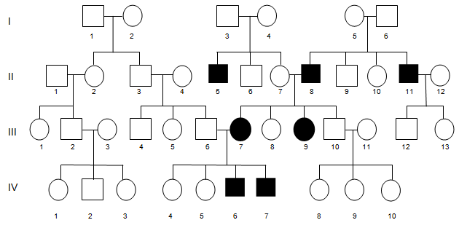

1. Using the pedigree chart, determine the mode of inheritance and explain how you were able to determine this. (3 marks)

_______________________________________________________________________________

_______________________________________________________________________________

_______________________________________________________________________________

_______________________________________________________________________________

_______________________________________________________________________________

_______________________________________________________________________________

1. Determine the probability that person III: 12 will inherit Ocular Albinism. Show all working in your answer. (4 marks)

**Question Four (8 marks)**

The pedigree below shows the inheritance of the condition neurofibromatosis. Neurofibromatosis refers to a number of inherited conditions that are clinically and genetically distinct and carry a high risk of tumour formation, particularly in the brain. Affected individuals, indicated here by the filled-in circles and squares, show symptoms of this condition.

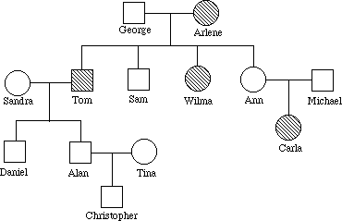

1. Given the information in the pedigree, name the type of inheritance neurofibromatosis displays and provide a reason for your answer. (2 marks)

_______________________________________________________________________________

_______________________________________________________________________________

1. Could it have been possible for Sandra and Tom to have a child that developed neurofibromatosis? Draw a punnet square and use it to explain your reasoning. (3 marks)

_______________________________________________________________________________

_______________________________________________________________________________

_______________________________________________________________________________

_______________________________________________________________________________

_______________________________________________________________________________

_______________________________________________________________________________

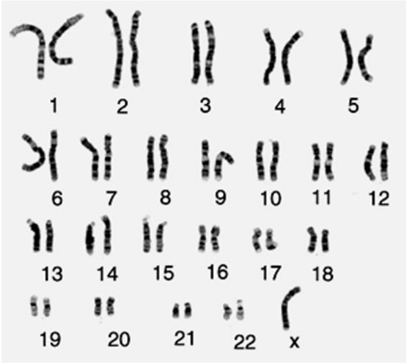Shown below is a karyotype of a person with Turner Syndrome.

c) The karyotype shown above was taken from an individual with Turner Syndrome. Turner’s syndrome is caused by a “monosomy X mutation”, explain what kind of mutation this is. (1 mark)

_______________________________________________________________________________

_______________________________________________________________________________

_______________________________________________________________________________

d) Explain why women with Turners syndrome have red-green colour blindness more frequently than women who do not have the mutation. (2 marks)

_______________________________________________________________________________

_______________________________________________________________________________

_______________________________________________________________________________

_______________________________________________________________________________

_______________________________________________________________________________

_______________________________________________________________________________

**Question Five (9 marks)**

Tay-Sachs is an autosomal recessive disorder. A couple with a history of Tay-Sachs in their families undergoes genetic screening before trying to conceive a baby.

1. It is found that Ellyn is a carrier for Tay-Sachs and her partner Noel is homozygous normal. Using a punnet square, predict the probability of their future children having the disease. Show full working out including genotypes and phenotypes. (4 marks)
2. The genetic counsellor drew a pedigree to show the couple how Tay-Sachs has been inherited in their families. In the space provided, draw the pedigree diagram the counsellor would have drawn. Include three labelled generations in the pedigree. (4 marks)

* Ellyn’s parents and Noel’s parents.
* The couple and their siblings. Ellyn is the younger of two girls; her sister was affected with Tay-Sachs. Noel is the oldest child, with a younger sister and an even younger brother who are all normal.
* The couple have two sons.

Indicate the individuals who have Tay-Sachs by shading the relevant circles or squares.

1. What would the genotypes be for Ellyn’s parents? (1 mark)

Father: _____________________________ Mother: _____________________________

**Question Six (6 marks)**

The ABO blood group system can be used as an example for two different types of genetic inheritance.

1. Describe these two types of inheritance using the ABO blood group system as an example for both (4 marks)

______________________________________________________________________________________

______________________________________________________________________________________

______________________________________________________________________________________

______________________________________________________________________________________

______________________________________________________________________________________

______________________________________________________________________________________

______________________________________________________________________________________

______________________________________________________________________________________

______________________________________________________________________________________

1. Complete the punnet square below and use it to explain how it is possible for two parents, one with blood type A and one with blood type B, to produce four children with four different blood types. (2 marks)

|  |  |  |  |
| --- | --- | --- | --- |
| *Punnet Square*  *Blood Types* | | Female | |
|  |  |
| Male |  |  |  |
|  |  |  |

_______________________________________________________________________________

_______________________________________________________________________________

_______________________________________________________________________________

_______________________________________________________________________________

_______________________________________________________________________________

_______________________________________________________________________________

**END OF TEST**